# Data Distributions (Multiple Gaussian)

For every step

Distribution = Gaussian * Cosine function * decaying exponential (As referred by the paper)

For each Gaussian distribution all the previous distributions are added

|  |  |  |  |
| --- | --- | --- | --- |
| Number of Gaussian distributions | Means | Variances | Sampling frequency for cosine |
| 1 | [3, 2] | [10 , 2], [2, 9] | 0.1 |
| 2 | [8,14] | [8,2],[2,10] | 0.2 |
| 3 | [13,14] | [9,1],[1,8] | 0.05 |
| 4 | [4,2] | [7,3],[3,8] | 0.3 |
| 5 | [10,15] | [11,3],[3,10], | 0.4 |

# Data Mean For Sensors

# 

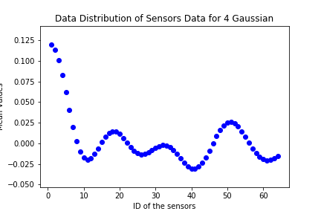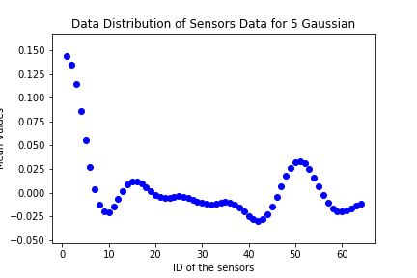

# Sensor Readings at different time stamps

# 1-Gaussian

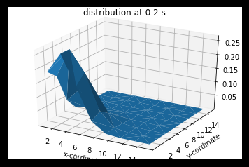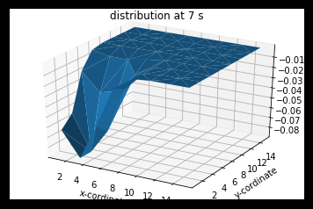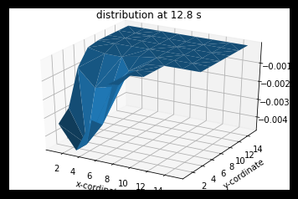

## 2-Gaussian

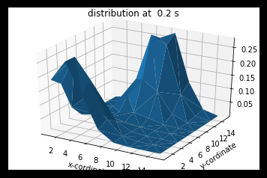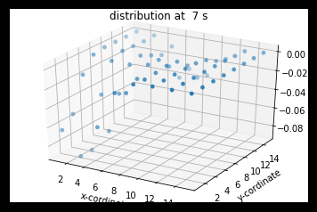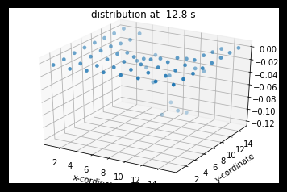

## 3 – Gaussian

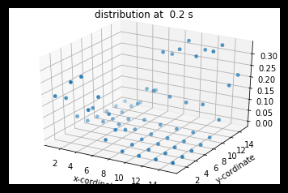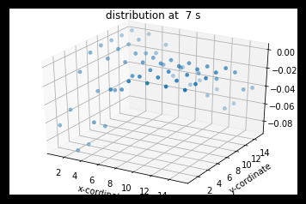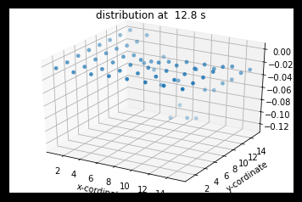

## 4-Gaussian

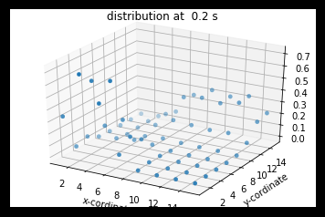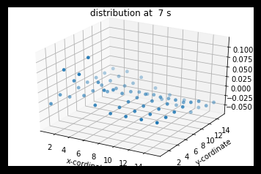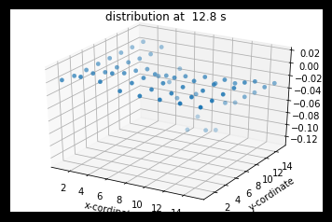

## 5-Gaussian

